### Does the increase in GHG emissions have an influence on Temperature?

Analysis was completed on the last 30 years (1991 – 2020) of recorded temperatures and greenhouse gasses in Australia.

### Temperatures

Monthly Australian temperature data was obtained from the World Bank Climate Knowledge Portal. A mean was calculated for all months in each year. The graph below demonstrates that there has been an upward trend in temperatures since 1990.

### Greenhouse Gasses

The CSRIO in Australia has been collecting monthly greenhouse gasses from the Cape Grim research station in Tasmania for over 40 years.

Together with the stations at Mauna Loa in Hawaii and Alert in the Canadian Arctic, Cape Grim is one of three premier Baseline Air Pollution Stations in the World Meteorological Organization-Global Atmosphere Watch (WMO-GAW) network.

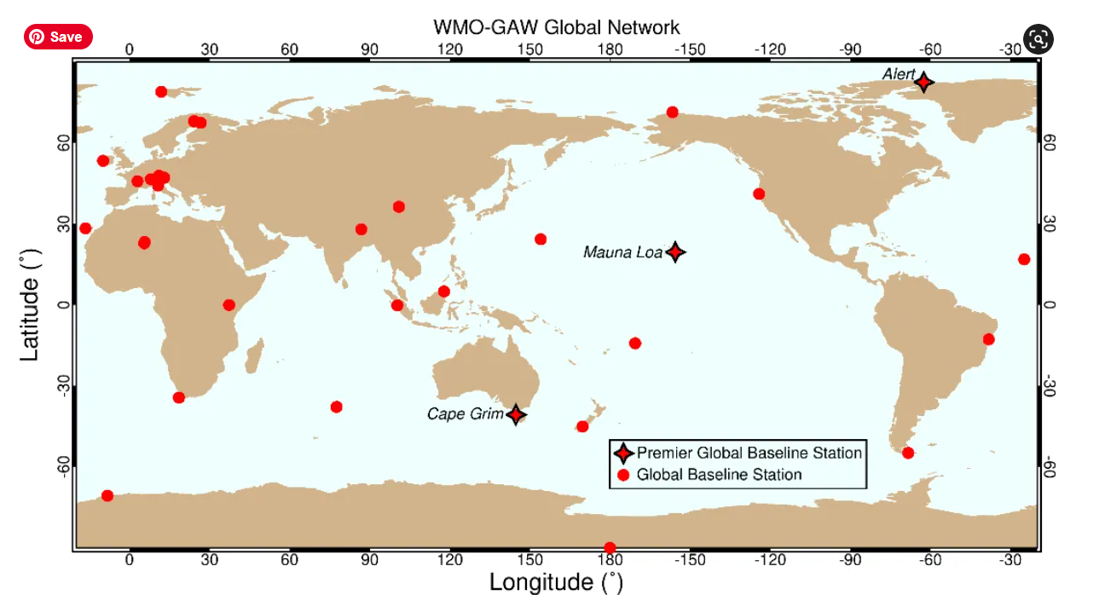

Three gasses measured as Cape Grim have been examined for this report:

1. Carbon Dioxide (ppm)
2. Methane (ppb)
3. Nitrous Oxide (ppb)

The following graphs show that all 3 gasses have increased in the atmosphere since 1990.

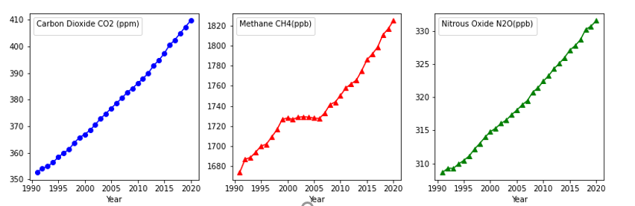

### Temperature versus Greenhouse Gasses

When comparing Temperature to Emissions it was found that there is a moderate positive relationship (r factor = 0.4) between the two. Therefore, it can be concluded that a rise in GHG emissions does influence the rise of temperatures in Australia. However, other climate factors should also be considered (e.g., el nino).

## References

Data for this report has been obtained from the following resources:

1. Temperature – Climate Knowledge Portal (World Bank)
2. Green House Gasses – CSRIO
3. Rainfall
4. Climate Knowledge Portal (World Bank)
5. Bureau of Meteorology (Australia)
6. Deforestation – Australian Department of Agriculture, Water and Environment
7. Bushfires – Wikipedia, Fire Departments website across Australia, Newspapers